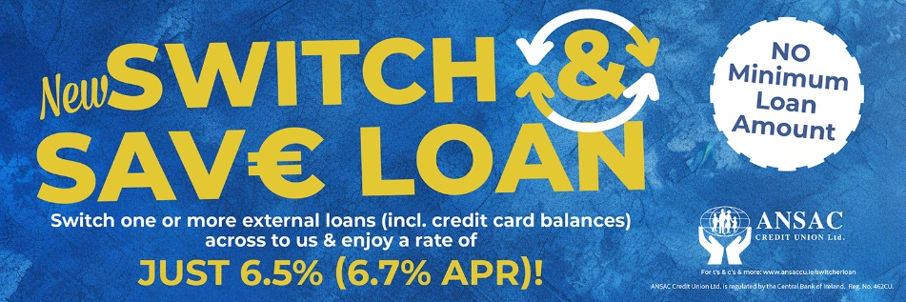

|  |  |  |  |  |  |
| --- | --- | --- | --- | --- | --- |
| Existing external loans that you’re considering switching | | | | | |
| Name of loan / credit card debt. | **Amount still owing** | **Remaining term** | **Typical APR\*** | **Monthly repayments** | **Cost of credit** |
| 1. | **€** |  |  | **€** | **€** |
| 2. | **€** |  |  | **€** | **€** |
| 3. | **€** |  |  | **€** | **€** |
| 4. | **€** |  |  | **€** | **€** |
| 5. | **€** |  |  | **€** | **€** |
| 6. | **€** |  |  | **€** | **€** |
| TOTAL | **€** |  |  | **€** | **€** |

#### *\*****Annual percentage rate (APR)*** *The APR is the annual rate of interest you will be charged on a loan. It takes account of all the costs involved over the term of the loan, such as any set-up charges and the interest rate. You can use the APR to compare different loans, as long as you compare them over the same term, for example 3-year loans.*

|  |  |  |  |  |  |
| --- | --- | --- | --- | --- | --- |
| New ANSAC 6.5% (6.7% APR) Switch & Save Loan | | | | | |
| Name of loan | **Amount still owing** | **Remaining term** | **Typical APR** | **Monthly repayments** | **Cost of credit** |
| ANSAC Switch & Save Loan. | **€** |  | **6.7%** | **€** | **€** |

|  |  |  |
| --- | --- | --- |
| **External Loans Combined Monthly Repayments:**  **€** | **Switch & Save Loan Monthly Repayment:**  **€** | **Potential reduction:**  **€** |

**Note: When deciding whether or not to switch loans it is important to consider all aspects from the repayment term, the total lifetime cost of the credit to your monthly repayments.**

**Should you require further assistance deciding if a Switch & Save Loan is a good option for you, please call us on 0189554489 & a member of the team would be delighted to assist you.**